
Testing Plan
  - Team Members: Demetrius Schank, John Ahn, Jonathan Kim
  - Due Date: 10/30/2025

User Group

The user groups for this project are cell imaging researchers, professors, and technicians working on characterizing imaged cells. They need to be able to detect cell deformation of a cell over a given time frame, and give characteristics like aspect ratio change, ROI (region of interest), center displacement, IoU (intersection of union) change, axis strain, and area change. These are a few characteristics that may indicate that a cell has changed shape between two points in time. What is unique about our user groups is that many of the users may not have captured their imaged materials themselves; they may be analyzing an existing study to come to new conclusions. Many users may not have the resources for high-powered cell imaging techniques and are thus limited in resources. This design needs to be accessible to that subset of users. Factors that affect the design of the project include multi-codec compatibility, meaning multiple video codecs need to be able to run with our design. All computations must be made in MATLAB only to limit external resources.

Constraints, Criteria, Specifications, and Standards

Constraints (yes, no)
- User Friendly
  - Design must be easy for first time users to use.
- Analysis Over Time
  - Design must analyze an instance of a cell over two points in time/two separate states.
- Discern Cell Boundaries in 2D Space
  - Design must be able to discern cell boundaries; Design must be able to parse object of interest and background.
- Exclusive use of MATLAB
  - Design must be created in MATLAB and use the MATLAB workspace.

Criteria (range)
- Affordable
  - Design must remain low cost outside of necessary resources that most users presumably already have. This includes their machine that will be running the code.
- Unique Cell Shape Detection
  - Design must be able to detect unique cell shapes, not just preset basic shapes of cells.
  - Add-on to constraint 3.
- Multi-Codec Compatibility
  - Design must support many types of video file types (.mp4, .avi, .mov, .wvm, etc.)

Specifications
- Analyzed File must be a Video File
  - Project is incompatible with just images alone.
- Red will be used for actively changing/most recently changed user input UI
- Green will be used for confirmed/least recently changed user input UI.
- Design will be tested using RBC and WBC cells
  - Uniform, simple shape in healthy conditions.
- Design will include feature of using real measurements.
Standards
- MISRA C:2023
  - MISRA is mainly for the motor industry, but since Matlab doesn’t really have a standard for security, the next best thing will be C/C++ due to Matlab being based off of those two langauges.
- https://www.mathworks.com/help/bugfinder/misra-c-2023-reference.html

Testing Summary
Test | Passing Criteria | C/C/S/S
Second sample test | The code works for a second video with a different scale, different cell structure, and varying video qualities. | Constraint: Applicability
Ease of usability test | The code is easy to use by people not familiar with MATLAB nor cell imaging | Constraints: User friendly
OS Compatibility test | The code works for different OS (Windows, MacOS, etc.) as long as MATLAB is used. This also includes different media types (mp4, avi, wav, etc.) | Constraints: Compatibility
Compliance Test | The code should follow the set of standards provided by MISRA. | Standard: MISRA C:2023
Deformation rate test  (future) | The measurements from the code are accurate and are within 5% of the measurements calculated manually  This test will be used for both fixed times as well as periods of time (this test will later be split into two tests) | Criteria: Measures cell deformation

Testing Plan

Second Sample Test
The second sample test will involve a sample video of cell(s) moving from a different study than the first sample video used. This test is to ensure that the code works for all potential users, varying camera qualities, and cells with different structures and properties.
Materials:
- A different sample video
- Matlab software (both application and online works)
- Most recent version of the code
Instructions:
- Upload the first sample video onto the code and run it. Make sure the code works as intended
- Upload a second sample video from a different study. Make sure the code works as intended.
Pass: The code works as intended for both sample videos. Confirm with at least two different samples but ideally have as many samples as possible.

Ease of Usability test
The ease of usability test will verify the constraint of having to be user friendly. It will ensure that people who have no background of MATLAB nor cell imaging can use it as a tool if the need for it comes up.
Materials:
- Group of people whose backgrounds of cell imaging varies
  - Researchers, graduate/undergraduate students focus on biology / cells, students not focused on biology/cells
- MATLAB software (both application and online works)
- Most recent version of the code
Instructions:
- Get a group of 100 people
- Show a simple demonstration of how the code works
- Let the people run code – ensure that everyone uses the same video
Pass: At least 95/100 people understand how to use the code as intended without help. This ensures that the code is easy to use for all people.

OS Compatibility Test
One of the most expensive materials for this project is laptops/PCs. The OS (operating system) compatibility test will ensure that the code works for any OS, so no one has to worry about buying a different OS. This test also makes sure that the code works on the MATLAB website, so users do not need a MATLAB subscription.
Materials:
- At least two different OS
  - Windows, MacOS, Linux
- MATLAB – application and website
- Most recent version of the code
Instructions:
- Load up laptops with different OS
  - Windows, MacOS, Linux, Android, Ubuntu
  - If unable to find these selected amounts, use virtual computers
- Show a simple demonstration of how the code works
- Run the same code on each OS
Pass: The code works for at least 3 out of the 5 mentioned (mainly Windows, MacOS, and Linux).

Compliance Test
The compliance test ensures that the code file follows the set of standards provided by MISRA (Motor Industry Software Reliability Association). Though the coding practices were initially targeted in the automobile industry, it is widely accepted for other industries like aerospace, industrial, and medical devices.
Materials:
- https://www.mathworks.com/help/bugfinder/misra-c-2023-reference.html
  - MISRA C Standard
- The Code file
Instructions:
- Ensure the code follows the guidelines in the MISRA C reference
- Double check each line of code to make sure it follows the standard.
- Go through the code as an entire team to make sure we understand it as a whole
- Comments in the code to ensure clarity
Pass: Every member of the team has their own notes on the code and understands it. The MISRA C standards are followed in our code.

Deformation Rate Test
The deformation rate test assures that the deformation measurements made by the code are accurate. This test is mainly for the ideal scenario where the code is fully automated, so for the time being the two compared measurements will be the one drawn using the current code and one measured manually. The latter measurements could be measured using AI tools.
Materials:
- Any OS that is compatible with the code / MATLAB
- Pen and paper, as well as AI
- Latest version of the code
Instructions:
- Run the code and follow instructions
  - Take the measurements of the two frames, and look at the inspector where all the measurements are given
- With the same two selected frames, have any AI take the measurements and produce the percentage it differs from the one you measured
Pass: We will say that the test pasts if the difference is under 5%.
Here is a quick sample of what it may look like:
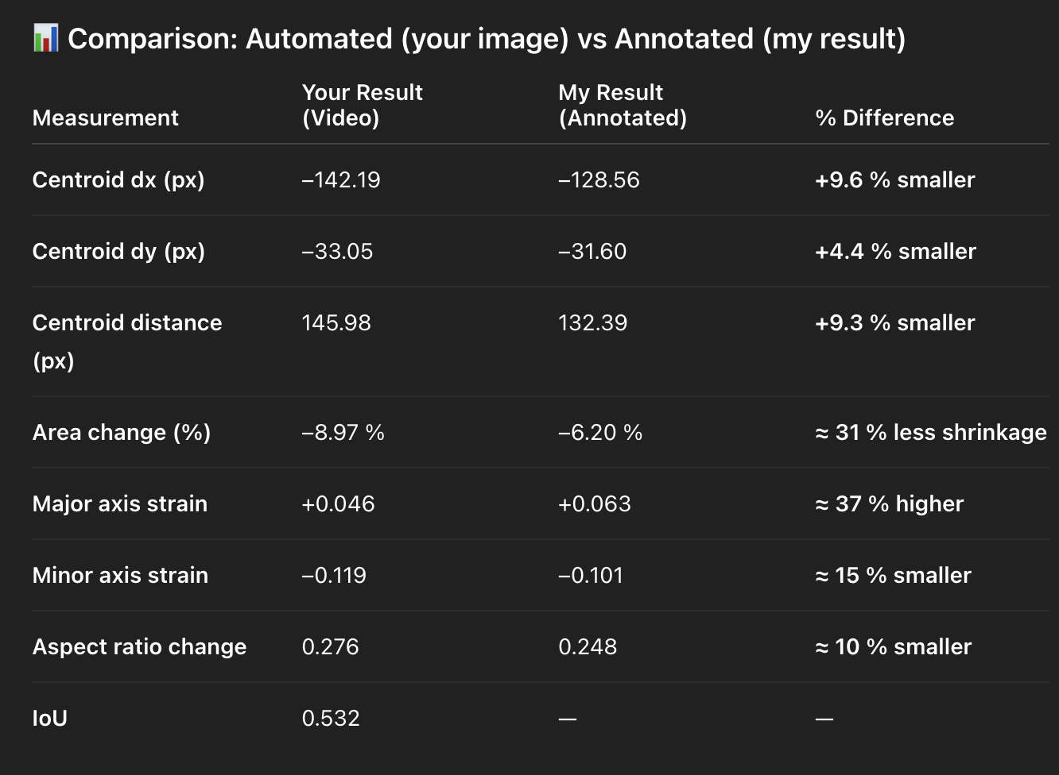
Things to think about:
Limitations: Volume, channel, AI’s limits on accurate pixel counting and detection

